Objective Questions for chapter 6

- If L is a regular language then, L^{c} is also :
  - Regular language
  - Non-regular language
  - Context Free Grammar
  - No Answer is correct

- If L₁ and L₂ are two regular languages, then L₁ U L₂ is also
  - Regular
  - Non-regular
  - Context Free Language
  - No answer in correct

- if r₁, r₂ are regular expressions, corresponding to the languages L₁ and L₂ then
  - the languages L₁ + L₂ , L₁L₂ and L₁* generated by r₁+ r₂, r₁r₂ and r₁*, are regular.
  - the languages L₁ + L₂ , L₁L₂ and L₁* generated by r₁+ r₂, r₁r₂ and r₁*, are non - regular.
  - the languages L₁ + L₂ , L₁L₂ and L₁* generated by r₁+ r₂, r₁r₂ and r₁*, are context free grammar.
  - No answer is correct.

- Let L be the language over the alphabet G = {a, b}, consisting of only two words aba and abb, then the FA accepting L may be

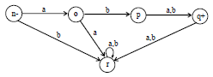
b.
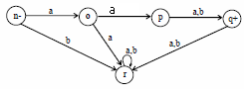
c.
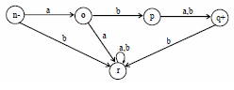

d.
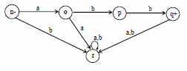

- Two machines are said to be equivalent if :
  - they print the same output string when the same input string is run on them.
  - they print the different output string when the same input string is run on them.
  - they print the same output string when the different input string is run on them.
  - All answers is correct.

- The input string that acceppted in mealy machine is :
  - Hexadecimal
  - Binary
  - Decimal
  - All answer is correct

- For every Mealy machine there is a Moore machine that is equivalent to it, with
  - ignoring the extra character printed the Moore machine.
  - ignoring the extra character printed the Mealy machine.
  - ignoring the extra character printed the Turing machine.
  - No Answer is correct

- Let L be a language defined over an alphabet G, then the language of strings, defined over G, not belonging to L, is called
  - Complement of the language L
  - Complement of the language G
  - Complement of the alphabet G
  - No answer is correct

- For a certain language L, the complement of L^{c} is
  - L^{c}
  - L
  - L’
  - All answer is correct

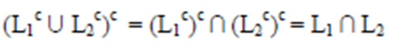
The formula above is the Law of
- De Jure
- De Morgan
- De Aan
- De Artagnan

